**Lesson 06 Demo 3**

**Setup Apache Server Using Ansible**



**Steps to be performed:**

1. Install Ansible on Ubuntu (You can skip this step in case Ansible is already installed)

2. Establish connectivity between Ansible controller and node machine

3. Write Ansible YAML script to install Apache server

4. Run Ansible YAML script

**Step 1: Install Ansible on Ubuntu** (You can skip this step in case Ansible is already installed)

1.1 Use the below commands on Ubuntu system to install ansible software.

***sudo apt-get install -f***

***sudo apt-get install software-properties-common***

***sudo apt-add-repository ppa:ansible/ansible***

***sudo apt-get update***

***sudo apt-get install ansible***

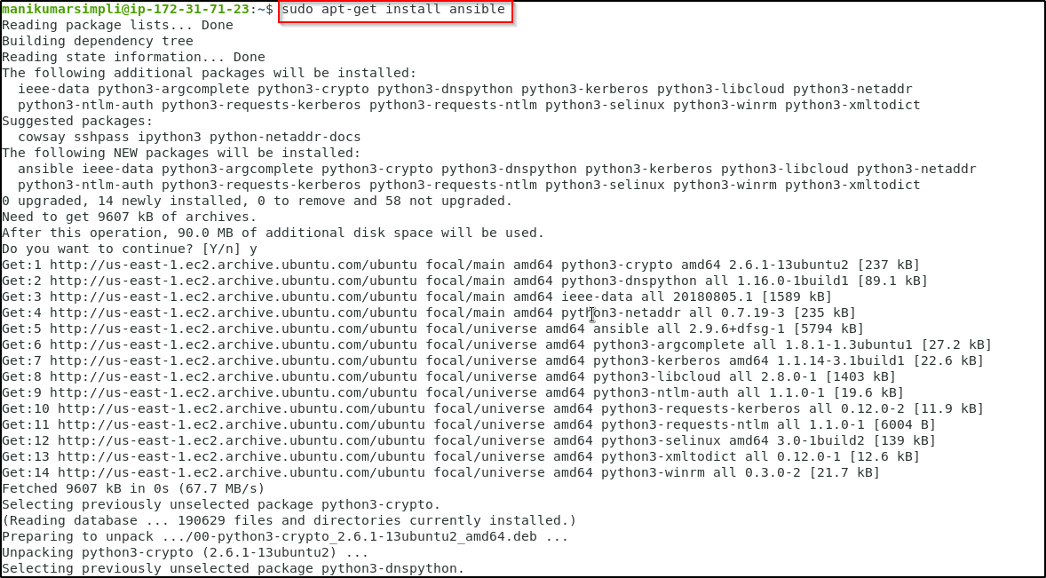

**Step 2: Establish connectivity between ansible controller and node machine**

2.1 Establish SSH key pair in linux system to have SSH connectivity with localhost using

the following command:

***ssh-keygen -t rsa (****Press Enter when asked for an input****)***

***cat .ssh/id_rsa.pub >> .ssh/authorized_keys***

***ssh localhost -p 42006***

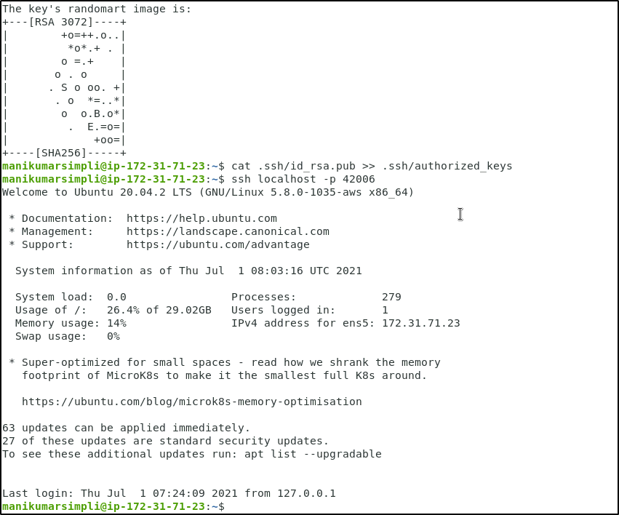

2.1 Now, add the host localhost in ansible host file ***/etc/ansible/hosts***

***sudo vi /etc/ansible/hosts***

2.2 When the file opens, add the below two lines of the code at the end of the file if not added already:

***[webservers]***

***localhost:42006***

2.3 Execute the below command to validate the host inventory file

***ansible -m ping webservers***

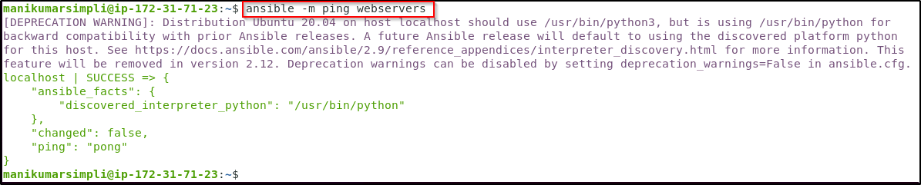

**Step 3: Write Ansible YAML script to install Apache software**

3.1 Once connectivity is established, add the following code in the apache.yaml file and

proceed with execution

3.2 Create and open the file using the below command

***sudo vi apache2.yaml***

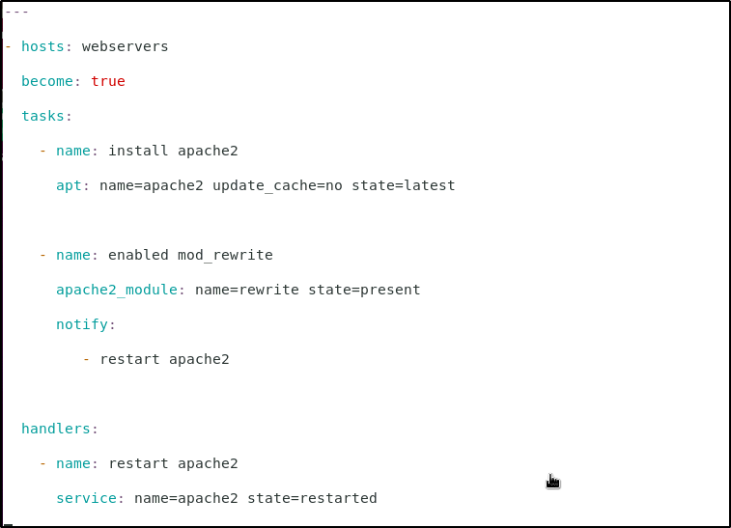

***---***

***- hosts: webservers***

***become: true***

***tasks:***

***- name: install apache2***

***apt: name=apache2 update_cache=no state=latest***

***- name: enabled mod_rewrite***

***apache2_module: name=rewrite state=present***

***notify:***

***- restart apache2***

***handlers:***

***- name: restart apache2***

***service: name=apache2 state=restarted***

**Step 4: Run Ansible YAML script**

4.1 Run ***apache.yaml*** file using the below command:

***ansible-playbook apache2.yaml***

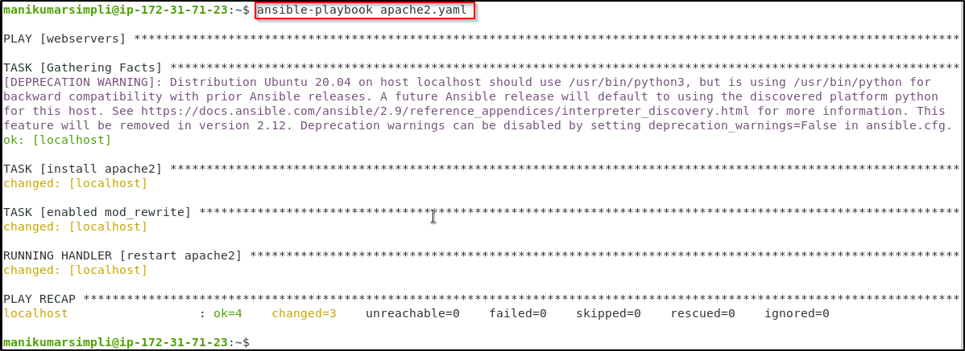

4.2 Validate the installation using the command:

***ansible -m shell -a "service apache2 status" webservers***

